Research Report

Telescope Scheduling

By:

Remek Botwright, Daniel English, Soren Richards, Luke Sapp

For:

Design and Analysis of Algorithms
CSC-2400-002
Christina Radian
Tennessee Technological University

December, 2025

- Introduction:

Telescope Scheduling algorithms are used in a lot of different ways. While they are primarily used for telescopes, they also have real world applications in areas like hospitals, manufacturing/assembly lines, transportation and logistics and any other area where large amounts of data must be weighted, prioritized, and executed.
There are many types of Telescope scheduling algorithms that vary in design, run time, and space efficiency. In this report our team analyzed three different kinds of telescope scheduling algorithms, those are: Greedy, Dynamic Scheduling, and Ant Colony Optimization.
Each of these algorithms have different qualities and design that will be explained in section 3 of this report.

- Algorithms:

To complete this project we wanted to choose 3 algorithms that would vary in run time and efficiency so that we could analyze the differences between them. We decided to analyze Greedy, Dynamic Scheduling, and Ant Colony Optimization .

2.1 greedy:

The greedy algorithm focuses on speed by always choosing the highest-priority or best-fitting task available at the current moment. It doesn’t look ahead or reconsider previous choices - once it picks a task, it commits and moves on. It’s fast, simple, and lives up to its name by always grabbing the “best” option right now.

2.2 Dynamic Scheduling:

A dynamic scheduling algorithm evaluates multiple possible task arrangements and stores intermediate results to avoid redundant calculations. Instead of making locally optimal choices, it considers how each task placement affects the overall schedule. This allows it to construct an optimal schedule through systematic comparison and step-by-step refinement.

2.3 Ant Colony Optimization:

Ant Colony Optimization (ACO) builds schedules by imitating how ants find efficient paths in the real world. Each “ant” creates its own version of a schedule, and the algorithm evaluates how well that attempt performs. Good solutions leave behind stronger digital “pheromones,” which act as breadcrumbs that guide future ants toward similar choices. At the same time, these pheromones slowly fade, preventing the algorithm from getting stuck on early ideas that happened to look good by chance. Over many iterations, this balance of reinforcement and evaporation helps ACO steadily move toward a consistently strong, well-structured schedule.
These three algorithms approach the problem of schedule generation in a different and unique way by prioritizing different things.

- Datasets
For this project, we made sure every algorithm worked with the exact same set of tasks. Each task contained basic information such as start time, end time, duration, and priority. Before running any algorithm, we reviewed the data to confirm that everything was valid—no missing values, no impossible time ranges, and nothing that could cause an algorithm to fail midway through.
Before running the algorithms, we completed a few key steps (a - d) to ensure the dataset was clean and consistent:

Standardizing the Format
We converted every task into the same structure so each algorithm interpreted the information the same way. This kept our comparisons fair and straightforward.

Organizing the Tasks
We sorted the tasks primarily by start time, and in some cases by priority. This made the scheduling process more efficient, particularly for algorithms that rely on ordered input, like the Greedy approach.

Checking for Errors
We reviewed the dataset for negative durations, unrealistic times, or any values that didn’t make sense. Anything incorrect was fixed or removed to prevent issues during execution.

Keeping It Consistent Across Tests
No matter which algorithm we were running, the dataset remained unchanged. The algorithms themselves were the only variable.
Because we handled the data this way, we could trust that our runtime and performance results reflected the algorithms themselves—not inconsistencies in the input.

- Experimental Setup

We used ChatGPT to help us generate a large set of realistic, real-world style datasets, which we then fed into each of our scheduling algorithms. In total, we created 1,000 consistent datasets, each containing start times, end times, and weights. Every dataset represented 1,000 scheduled tasks spread across a 12-hour window.
We built a Python script to run all three algorithms across every dataset, printing the resulting schedules to the terminal and recording the runtime for each one. To make analysis easier later, the program also saved the full output schedule from the first dataset for each algorithm into its own separate file.

- Results
Because the datasets were so large, working through all of them became increasingly time-consuming, especially when running the Ant Colony Optimization (ACO) algorithm. To keep the testing process manageable, we reduced the number of schedules from 1,000 to 100 so we could run more focused and consistent experiments.
In terms of performance, Greedy and Dynamic were significantly faster than ACO. On average, Greedy finished in under 0.001 seconds, Dynamic finished in under 0.3 seconds, and ACO took close to 40 seconds per schedule. Greedy and Dynamic also produced nearly identical schedules, especially when weights played a major role, while ACO’s results were noticeably different.
One of the biggest challenges came from adjusting the number of ants in ACO. Increasing the ant count improved solution quality, but it also caused the runtime to grow quickly. Once we passed around 20 ants, a single schedule could take up to 10 minutes to complete. Because we used a smaller number of ants to keep the tests practical, the ACO schedules ended up being less optimal than they could have been with higher ant counts.

- Graphs
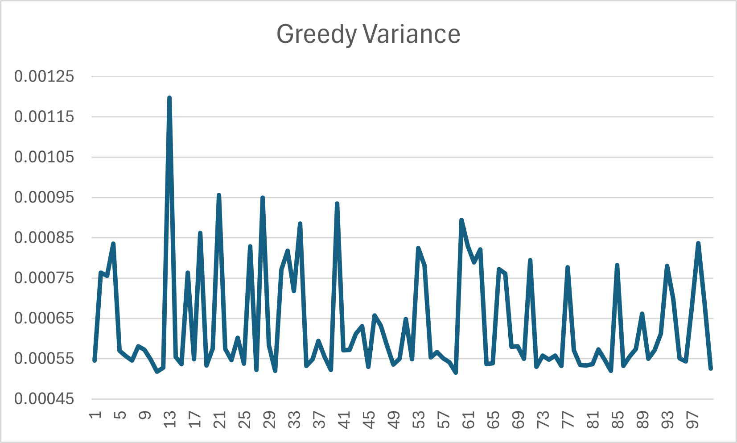
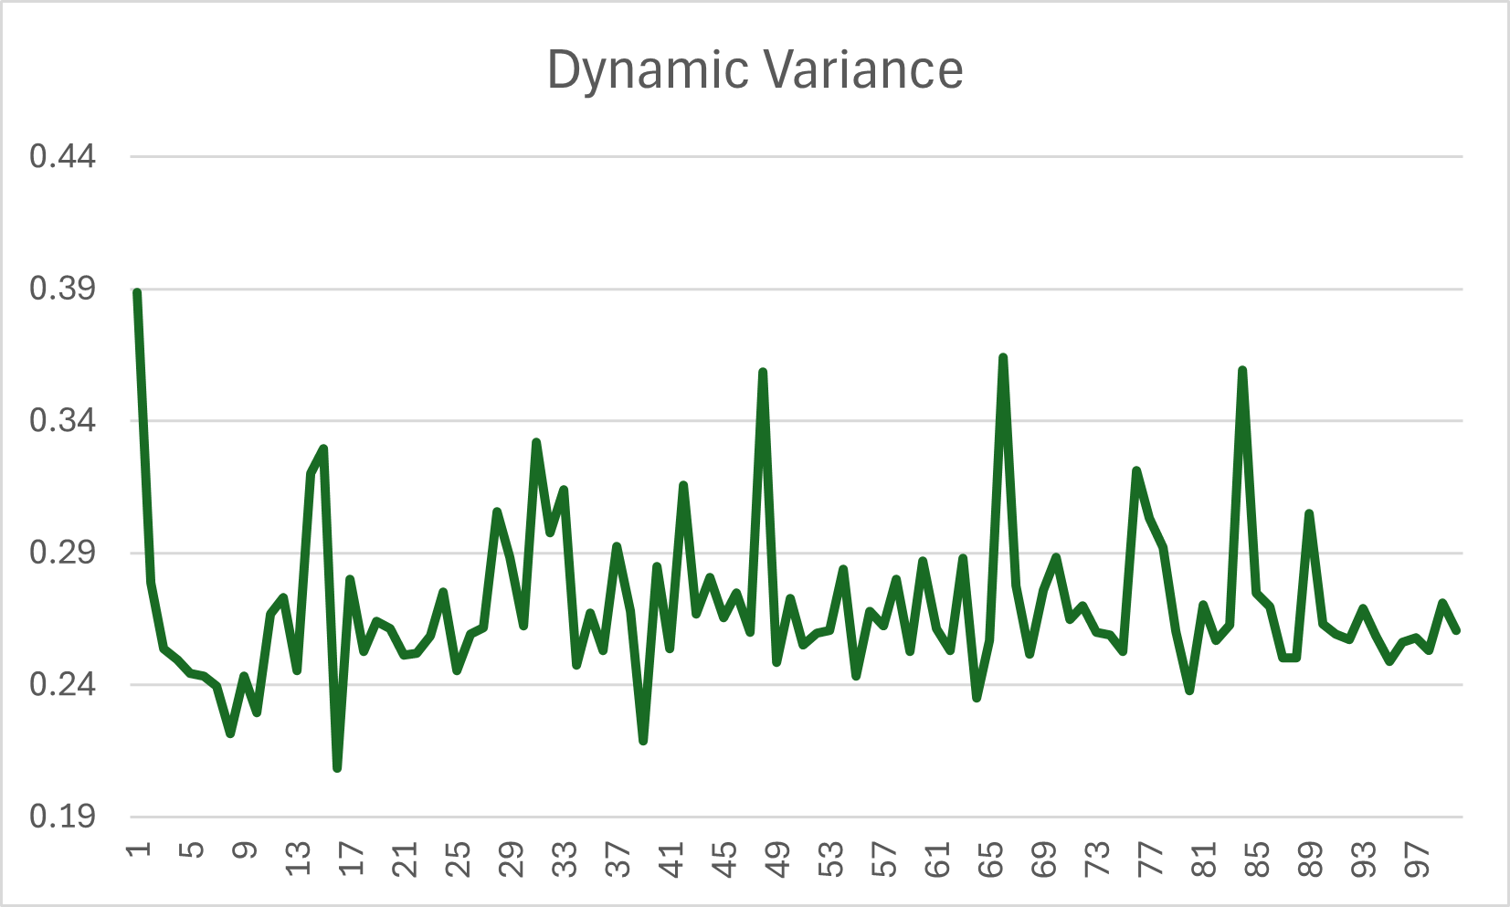
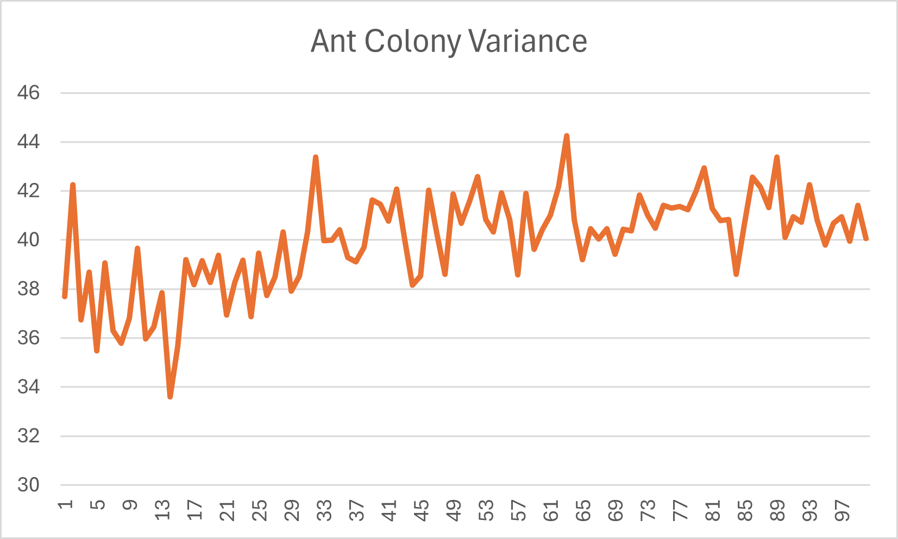
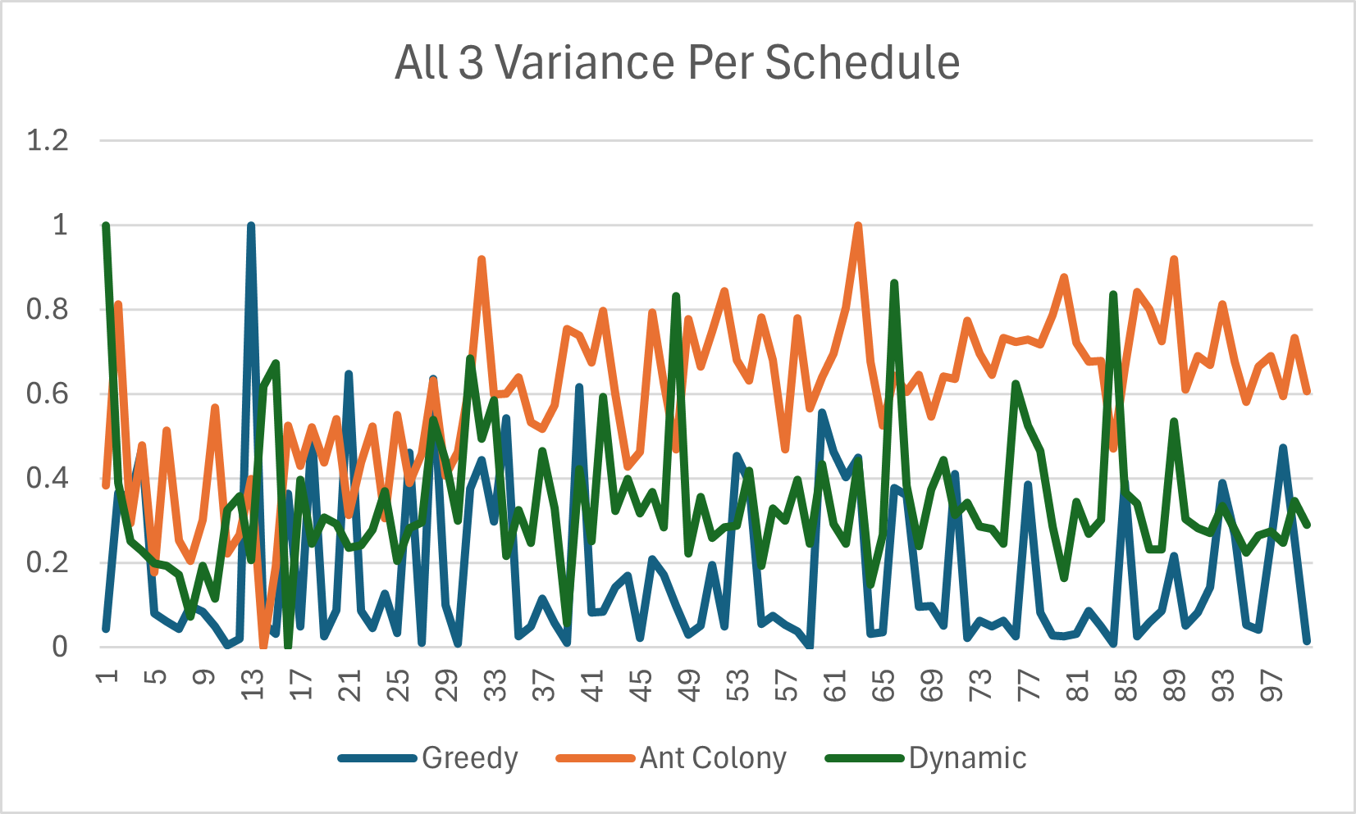
- Discussion
Because the schedules were weighted and the algorithms were tested across such a large number of datasets, the Dynamic and Greedy approaches ended up being far more practical than Ant Colony Optimization. ACO tends to work best in situations with fewer datasets, where taking more time per schedule isn’t a major concern. In our case, the scale of the data made Greedy and Dynamic the more efficient and reliable choices.

- Conclusion
Both the Greedy and Dynamic algorithms produced the same results when using weighted schedules. When factoring in overall runtime over large datasets, Greedy is the most practical choice. With faster execution and scaling. Dynamic can perform well, and produce solid results, but will take longer than Greedy. Ant Colony is irrelevant as the total amount of schedules increases, and the cost of getting strong results is far more taxing in terms of resources than Greedy or Dynamic.

